Q1:

1. Applying Ljung-Box Test on the log returns of Starbucks stock $\left(r_{t}\right)$, $H_{0}$ was rejected and thus there is serial correlation.

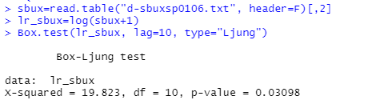

1. Since $r_{t}$ has serial correlation, AR(1) model was fitted to remove the serial dependence.

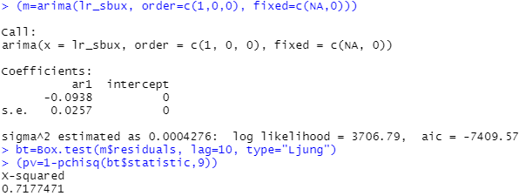

The residuals is given by $a_{t}=r_{t}+0.0938r_{t-1}$

The ARCH effect of $r_{t}$ was tested by applying Ljung-Box Test on $a_{t}^{2}$. $H_{0}$ was rejected and thus there is ARCH effect in the log returns of Starbucks stock.

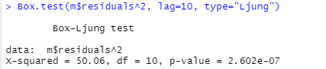

1. GARCH(1,1) model was fitted on $r_{t}$. Results of the Ljung-Box Test on the standardized residuals and standardized squared residuals show that the model is adequate. The fitted model is:

$r_{t}=0.0012327+a_{t}$, $a_{t}=σ_{t}ϵ_{t}$ and

$$σ_{t}^{2}=1.5944×{10}^{-6}+0.019645a_{t-1}^{2}+0.97612σ_{t-1}^{2}$$

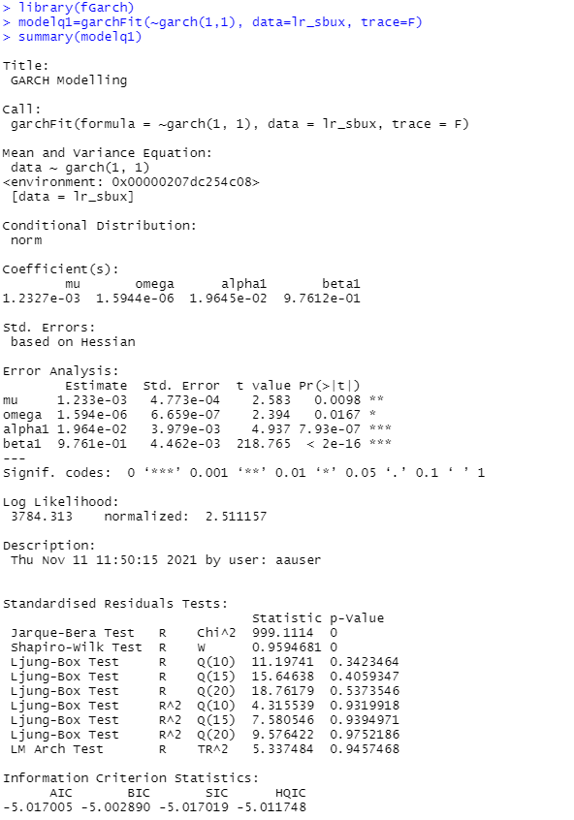

Q2:

1. Applying Ljung-Box Test on the log returns of S&P index $\left(r_{t}\right)$, $H_{0}$ was not rejected and thus there is no serial correlation.

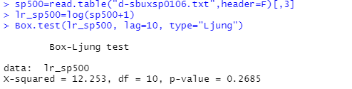

1. The ARCH effect of $r_{t}$ was tested by applying Ljung-Box Test on $a_{t}^{2}={\left(r_{t}-μ\right)}^{2}$. $H_{0}$ was rejected and thus there is ARCH effect in the log returns of Starbucks stock.

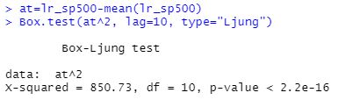

1. IGARCH(1,1) model was fitted on $r_{t}$. Results of the Ljung-Box Test on the standardized residuals and standardized squared residuals show that the model is adequate. The fitted model is:

$r_{t}=0.000398+a_{t}$, $a_{t}=σ_{t}ϵ_{t}$ and

$$σ_{t}^{2}=0.067459a_{t-1}^{2}+0.932541σ_{t-1}^{2}$$

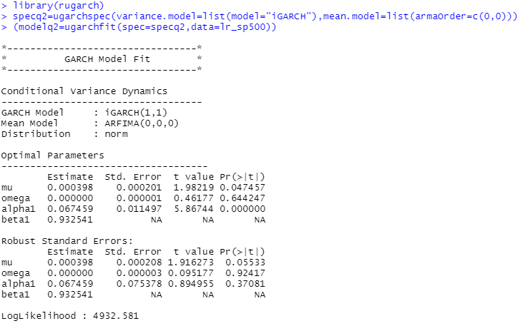

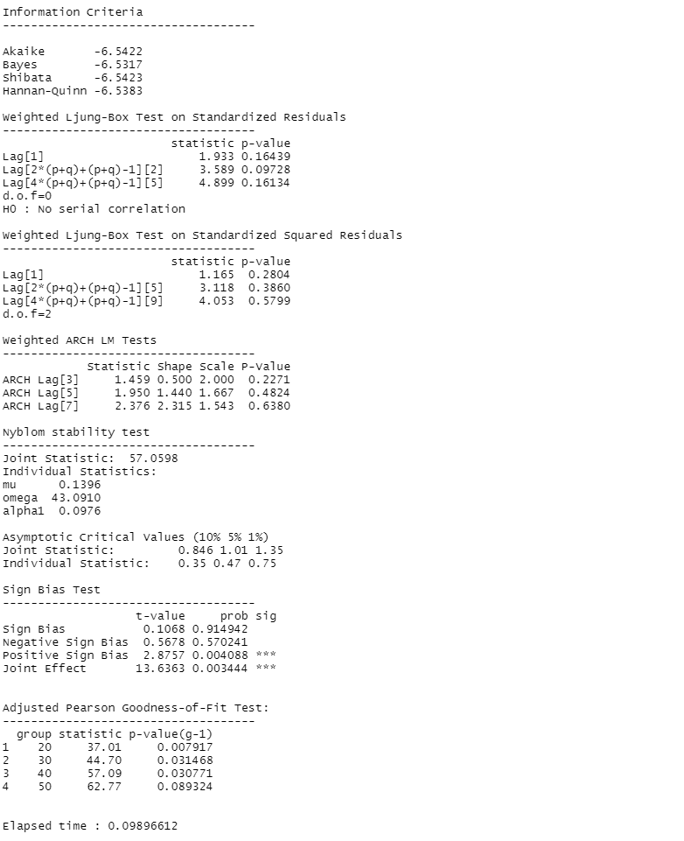

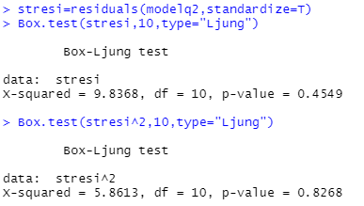

1. The 1- to 4-step ahead forecast for $r_{t}$ have the same value: 0.0003982, and the 1-step forecasting interval is given by:

$$\left[0.0003982-1.96×0.005002, 0.0003982+1.96×0.005002\right]=[-0.00940572, 0.01020212]$$

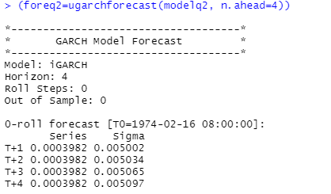

Q3:

1. GARCH(1,1)-M model was fitted on the log returns of Starbucks stock $\left(r_{t}\right)$. The fitted model is:

$r_{t}=0.001953-2.05779σ_{t}^{2}+a_{t}$, $a_{t}=σ_{t}ϵ_{t}$ and

$$σ_{t}^{2}=2×{10}^{-6}+0.019471a_{t-1}^{2}+0.976314σ_{t-1}^{2}$$

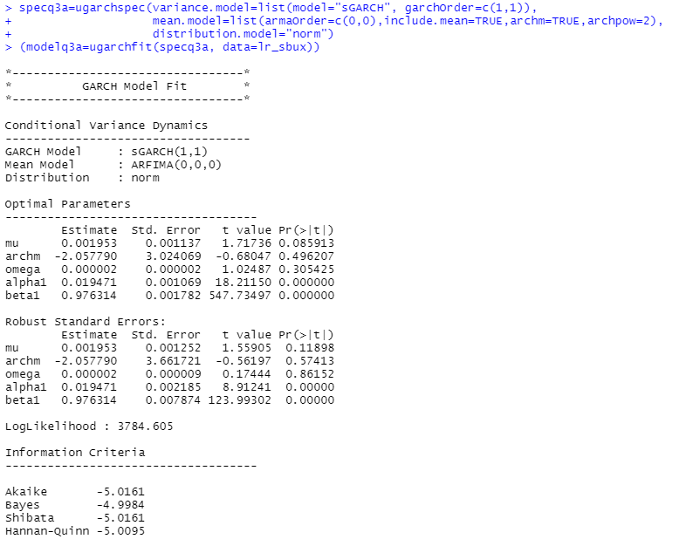

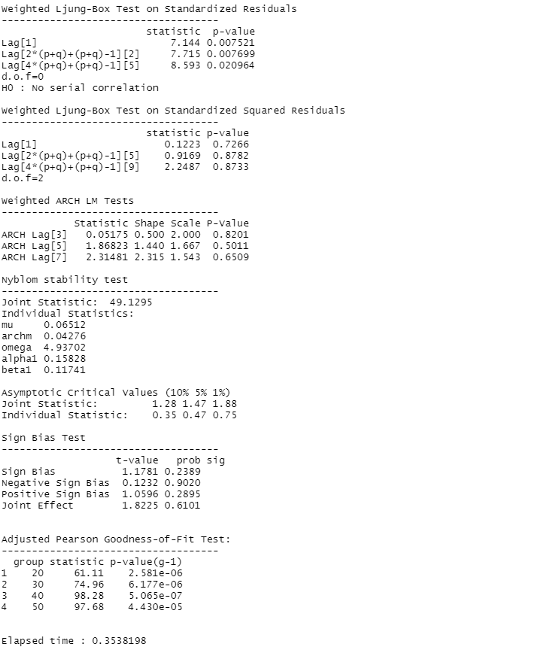

1. As the p-value=0.496207 is large, the ARCH-in-mean parameter is not significant at the 5% level.
2. EGARCH(1,1) model was fitted on $r_{t}$ with R package “rugarch”. The model is in the form:

$r_{t}=μ+a_{t}$, $a_{t}=σ_{t}ϵ_{t}$ and

$$\ln\left(σ_{t}^{2}\right)=ω+αϵ_{t-1}+γ\left(\left|ϵ_{t-1}\right|-E\left|ϵ_{t-1}\right|\right)+βln⁡(σ_{t-1}^{2})$$

Note that $ϵ_{t-1}=\frac{a_{t-1}}{σ_{t-1}}$, $σ_{t-1}>0$ and $E\left|ϵ_{t-1}\right|=\sqrt{\frac{2}{π }}$, we have

$$\ln\left(σ_{t}^{2}\right)=ω+α\frac{a_{t-1}}{σ_{t-1}}+γ\left(\frac{\left|a_{t-1}\right|}{σ_{t-1}}-\sqrt{\frac{2}{π }}\right)+βln⁡(σ_{t-1}^{2})$$

Results of the Ljung-Box Test on the standardized residuals and standardized squared residuals show that the model is adequate. The fitted model is:

$r_{t}=0.000917+a_{t}$, $a_{t}=σ_{t}ϵ_{t}$ and

$$\ln\left(σ_{t}^{2}\right)=-0.050023-0.039493\frac{a_{t-1}}{σ_{t-1}}+0.047902\left(\frac{\left|a_{t-1}\right|}{σ_{t-1}}-0.797885\right)+0.993387\ln\left(σ_{t-1}^{2}\right)= -0.0882433-0.039493\frac{a_{t-1}}{σ_{t-1}}+0.047902\frac{\left|a_{t-1}\right|}{σ_{t-1}}+0.993387\ln\left(σ_{t-1}^{2}\right) =\left\{\begin{aligned}-0.0882433+0.008409\frac{a_{t-1}}{σ_{t-1}}+0.993387\ln\left(σ_{t-1}^{2}\right) , for a_{t-1}≥0 \\ -0.0882433-0.087395\frac{a_{t-1}}{σ_{t-1}}++0.993387\ln\left(σ_{t-1}^{2}\right) , for a_{t-1}<0\end{aligned}\right.$$

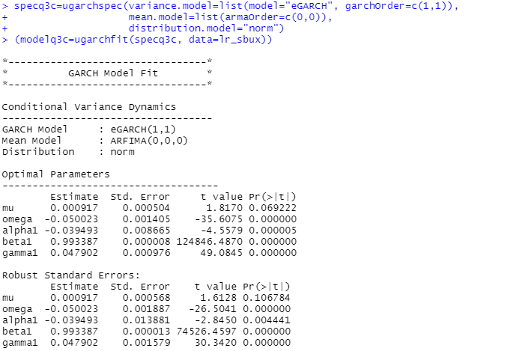

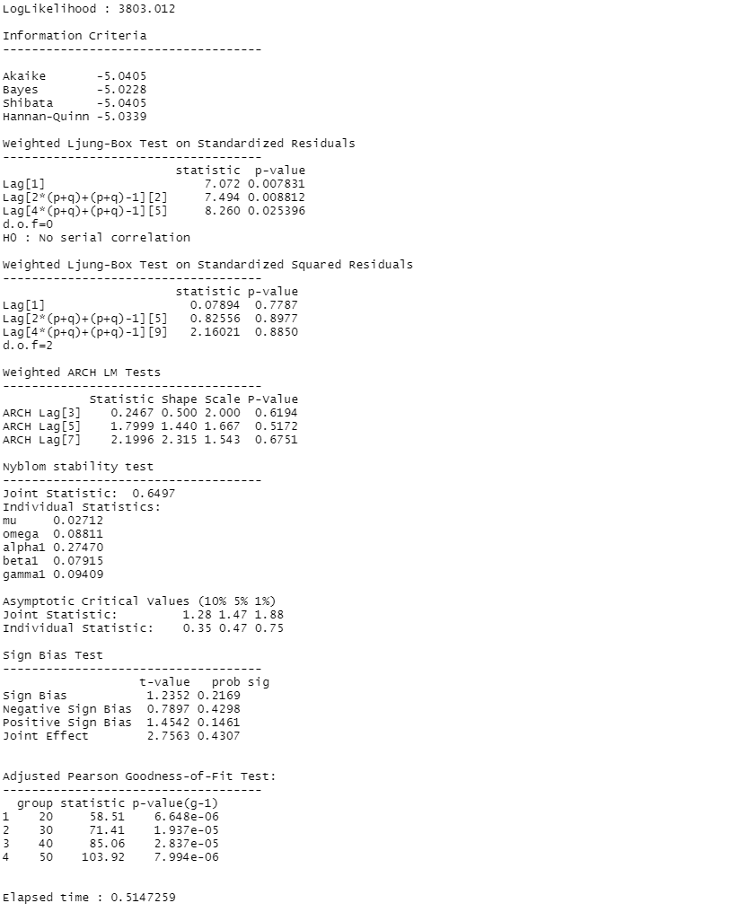

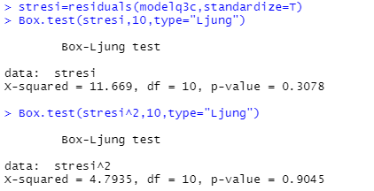

1. As the p-value of the leverage parameter ($\frac{α}{γ}$) is very small, the leverage parameter is significant.

Q4:

1. Applying Ljung-Box Test on the log returns of PG stock $\left(r_{t}\right)$, $H_{0}$ was not rejected and thus there is no serial correlation.

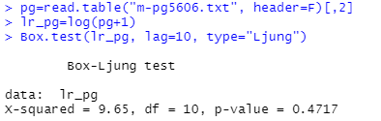

1. GARCH(1,1) model was fitted on $r_{t}$. Results of the Ljung-Box Test on the standardized residuals and standardized squared residuals show that the model is adequate. The fitted model is:

$r_{t}=0.0085624+a_{t}$, $a_{t}=σ_{t}ϵ_{t}$ and

$$σ_{t}^{2}=8.5366×{10}^{-5}+0.096309a_{t-1}^{2}+0.8624σ_{t-1}^{2}$$

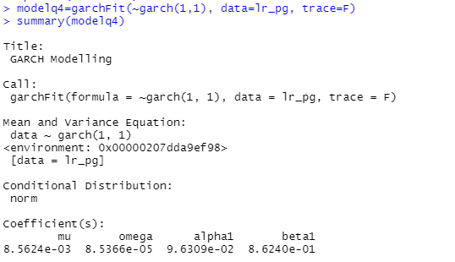

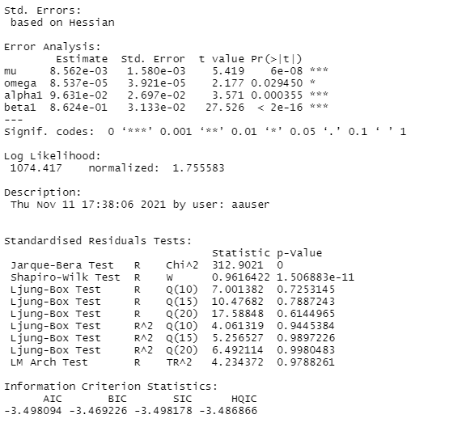

1. The 1- to 5-step ahead forecast for $r_{t}$ have the same value: 0.008562431, and the 1-step forecasting interval is given by:

$$\left[0.008562431-1.96×0.02952353, 0.008562431+1.96×0.02952353\right]=[-0.0493037, 0.0664285]$$

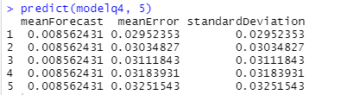

Q5:

1. Applying Ljung-Box Test on the log returns series $\left(r_{t}\right)$, $H_{0}$ was not rejected and thus there is no serial correlation.

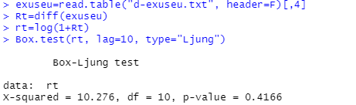

1. The ARCH effect of $r_{t}$ was tested by applying Ljung-Box Test on $a_{t}^{2}={\left(r_{t}-μ\right)}^{2}$. $H_{0}$ was rejected and thus there is ARCH effect in the log return series.

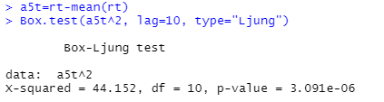

1. IGARCH(1,1) model was fitted on $r_{t}$. Results of the Ljung-Box Test on the standardized residuals and standardized squared residuals show that the model is adequate. The fitted model is:

$r_{t}=0.000085+a_{t}$, $a_{t}=σ_{t}ϵ_{t}$ and

$$σ_{t}^{2}=0.018743a_{t-1}^{2}+0.981257σ_{t-1}^{2}$$

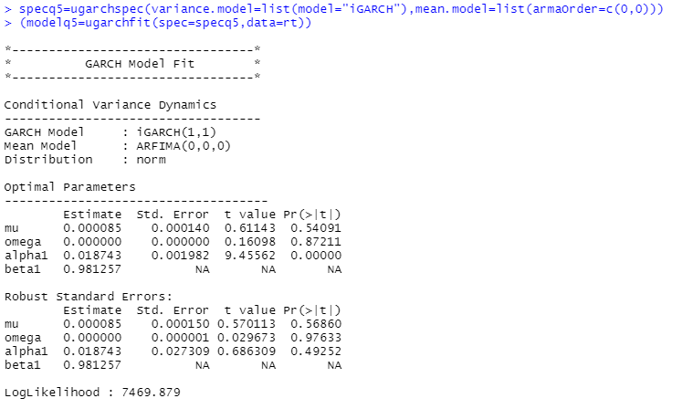

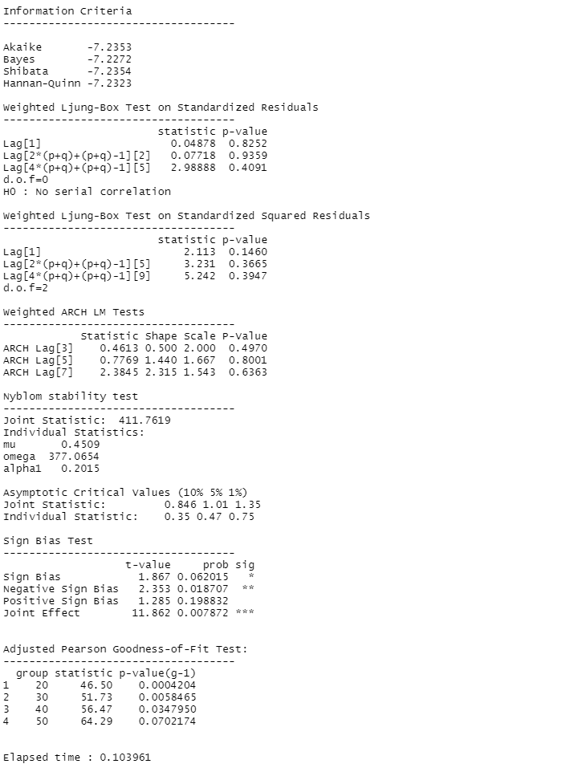

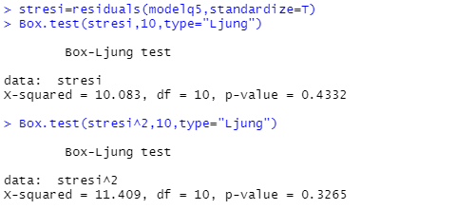

1. The 1- to 4-step ahead forecast for $r_{t}$ have the same value: 0.00008539, and the 1-step forecasting interval is given by:

$$\left[0.00008539-1.96×0.004853, 0.00008539+1.96×0.004853\right]=[-0.00942649, 0.00959727]$$

